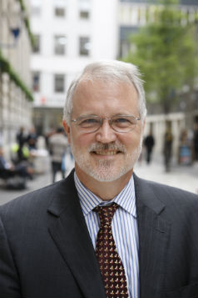
LSE Director, Prof. Craig Calhoun
Professor Calhoun is a world-renowned social scientist whose work connects sociology to culture, communication, politics, philosophy and economics.
He took up his post as LSE Director on 1 September 2012, having left the United States where he was University Professor at New York University and director of the Institute for Public Knowledge. From 1999 to 2012, he served as President of the Social Science Research Council in the USA.
Professor Calhoun received his doctorate in sociology from the University of Oxford. He taught at the University of North Carolina at Chapel Hill for 19 years, serving also as Dean of the Graduate School and Director of the University Center for International Studies. He has also taught at Columbia University and as a visiting professor in China, Eritrea, France, Norway, and Sudan.
He has been a Council member, Chair of three sections, and Member or Chair of Program, Publications and International Sociology committees in the American Sociological Association (ASA) and editor of its journal Sociological Theory; Program Chair of the Social Science History Association (SSHA); member of the Executive Committee of the International Social Science Council; Board Member of the Center for Advanced Study in the Behavioral Sciences, the Center for Transcultural Studies, the New School for Social Research, the Council for International Exchange of Scholars, the Harvard University Board of Overseers, the Fondation Dogan and the Fondation Bourdieu. He is a Fellow of the American Association for the Advancement of Science (AAAS), a Member of the Council on Foreign Relations, and has received a range of prizes and an honorary doctorate.
He is the author of several books including Nations Matter, Critical Social Theory, Neither Gods Nor Emperors and most recently The Roots of Radicalism (University of Chicago Press, 2012).
Describing his own approach to academic work, Professor Calhoun says: "We must set high standards for ourselves, but in order to inform the public well, not to isolate ourselves from it."

