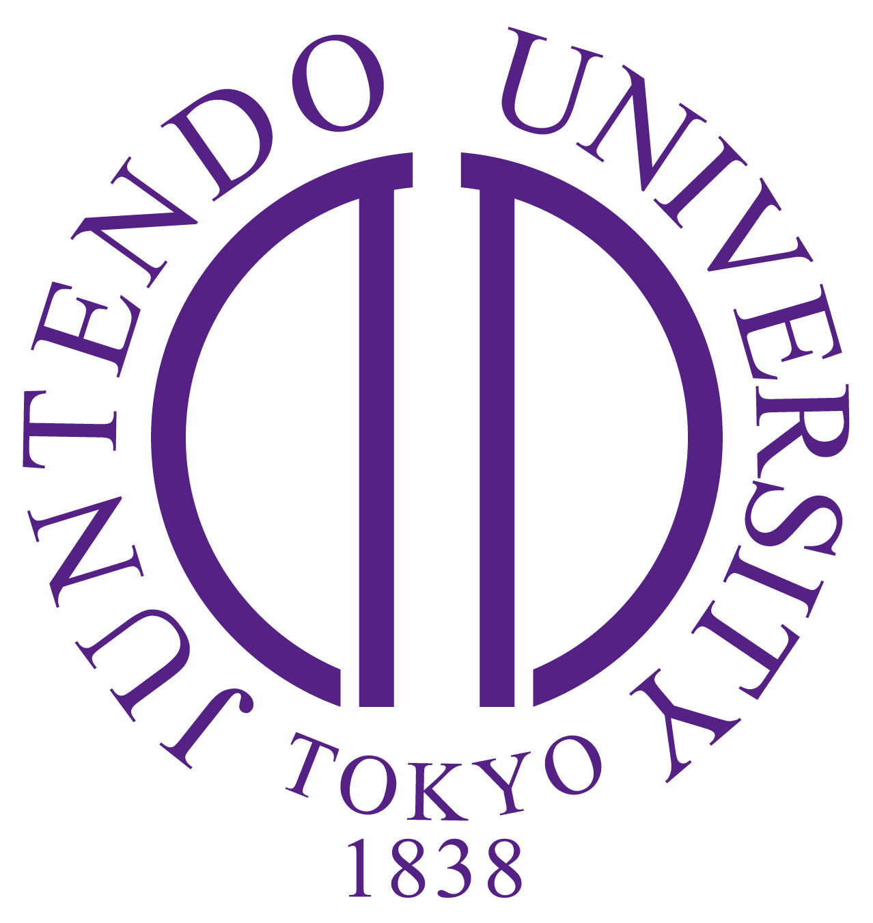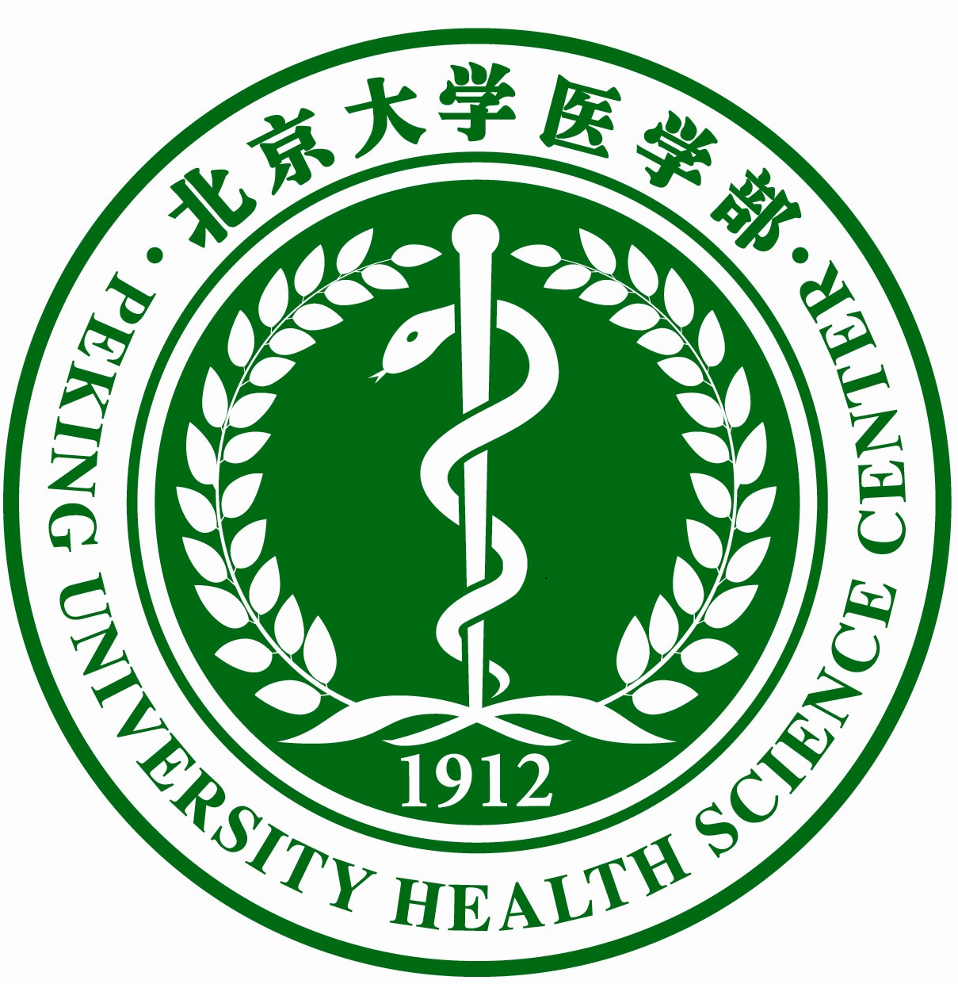

**PKUHSC-JUNTENDO Joint Institute for Medical Research**

**CALL FOR PROPOSALS**

**2025**

**Purpose**

Peking University Health Science Center (PKUHSC) and Juntendo University (JUNTENDO) Joint Institute for Medical Research (JI) seeks to identify joint proposals that advance robust collaborations between the institutions that will lead to transformative science and future extramural funding. Proposals must be jointly put forth by Co-Principal Investigators who are full-time faculty at JUNTENDO and PKUHSC.

**Overview**

PKUHSC-JUNTENDO Joint Institute for Medical Research was officially launched in October 2022 with a combined commitment of 6 million CNY (approximately 120 million JPY) per year for joint research projects on diseases that are important to Japan and China. In July 2016, the Memorandum of Understanding between Juntendo University and PKUHSC was renewed and will continue to be effective until both parties mutually agree to terminate it.

In the initial phase, research programs will focus on cardiovascular diseases, cerebrovascular diseases, big data, neuroscience, mental health, hematology, hospital management and other fields of interest to researchers from both universities. Priority is given to the faculty with the established collaboration and demonstrated significant collaborative research outcomes. Proposals that align or inform clinical research will be favored. Successful proposals will be those that leverage the unique strengths of each university that are difficult for either JUNTENDO or PKUHSC to pursue alone.

**Awards**

Funding for all awards originate equally from JUNTENDO and PKUHSC with the intent that the respective amounts will be spent within the originating country. PKUHSC-JUNTENDO Joint Institute for Medical Research aims to grant a total of 6,000,000 CNY (approximately 120,000,000 JPY) in this call. Proposals can request the necessary funding amount for the delivery of their project.

There are two types of awards this year:

* **Discovery Awards:**
  + Funding level: up to 400,000 CNY (approximately 8,000,000 JPY)( 200,000 CNY from PKUHSC and 200,000 CNY from JUNTENDO) for two years.
  + Purpose: to promote collaborations that have yet to be fully established.
* **Pilot Awards:** 
  + Funding Level: up to 1,000,000 CNY (approximately 20,000,000 JPY) (500,000 CNY from PKUHSC and 500,000 CNY from JUNTENDO) for two years.
  + Purpose: to strengthen partnership between the investigators who have demonstrated track-record of collaboration between the two institutions. This award category also includes proposals that are considered as interventional clinical trials.

**Eligibility**

The Call is open to all Academic Departments, Research Institutes, Centers and Groups related to health sciences at JUNTENDO and PKUHSC. Proposals must be jointly put forth by co-principal investigators who are full-time faculty at JUNTENDO and PKUHSC.

**Submission Due Date & Review Timeline**

* Announcement of Requests for Proposals May 12, 2025
* Submission for Full Proposals June 25, 2025
* Notice of Award September 15, 2025

**Submission Process**

Please submit all documents as a single PDF file, including a request for notice of receipt to: SUGIYAMA Yukihiro (sugiyuki@juntendo.ac.jp), SUN Qiudan (sunqd@bjmu.edu.cn), WANG Jiancheng ([wang-jc@bjmu.edu.cn](mailto:wang-jc@bjmu.edu.cn)) and XU Ming ([xuminghi@bjmu.edu.cn](mailto:xuminghi@bjmu.edu.cn)), cc to International Collaborative Research Administration of Juntendo University ([icra@juntendo.ac.jp](mailto:icra@juntendo.ac.jp)), LI Xiaojia ([lixiaojia@bjmu.edu.cn](mailto:lixiaojia@bjmu.edu.cn)), ZHAO Chunhui (zhaoch@bjmu.edu.cn), ZHENG Lemin ([zhengl@bjmu.edu.cn](mailto:zhengl@bjmu.edu.cn)), BAI Jing ([yiyingbaijing@bjmu.edu.cn](mailto:yiyingbaijing@bjmu.edu.cn)) and CAO Yuan ([caoyuan9004@bjmu.edu.cn](mailto:caoyuan9004@bjmu.edu.cn)).

**Required Elements of Full Proposal**

1. Completed and Signed Face Page (Appendix 1: Face Page Template):
   1. Project Title
   2. Name, signatures of PIs and Department Chairs with contact information from both Juntendo University and PKUHSC
   3. Requested funding for each institution with a total broken out by project year
2. Project Description

* Formatting requirement: single spaced, 11 pt. font in Calibri or Arial.
  + Page limits: 5 pages

The full proposal should include the following sections:

1. Executive summary
2. Objectives (no more than 4)
3. Background: Existing status quo/state-of-the-art and challenges
4. Research Strategy and Methodology:
   * 1. Experimental design/rationale
     2. Description of major tasks and respective task leaders
     3. Proposed timeline for major tasks and milestones
     4. Future directions and research plans for the next three years
     5. Opportunity for subsequent funding (beyond the scope of the seed project)
5. Plan for Protection of Human Subjects
6. Biosketch of Key Personnel (see Appendix 2: Biographical Sketch Template)
7. Plans (if any) for interchange of personnel between institutions (include: name of mentors and trainees, training time frame, training objectives/curriculums/activities, description of the trainees’ major role in the project)
8. Identification of Project-relevant Background Intellectual Property (if applicable)
9. Letters of support from Department or Divisional Chair
10. Budget and Justification (Appendix 3: Budget Template):

Line item budget:

1. Personnel:
   * up to 50% of total budget
   * PKUHSC personnel budget limits to temporary research members
   * name/role on project
   * percentage of effort
   * base salary/fringe benefits
   * tuition and stipend shall not be included in the JI budget
2. Supplies/materials
3. Participant fees/costs (i.e., expenses per participant including travel, tests, payment for time)
4. Travel (for PIs to meet face to face in Tokyo/Beijing and attend the annual Joint Institute symposia)

Budget justification:

For each category above briefly describe and provide justification for each item. Costs must be broken out for both Juntendo University and PKUHSC participants. Lodging and other living expenses are to be borne by the home institutions of the visiting researchers.

**Evaluation of Project Proposals**

Proposals will be reviewed by peer reviewers familiar with the content areas and funding environment in the Japan and China respectively, in making the selection of successful proposals:

* Significance: impact and significance of the work
* Investigators: qualifications of PIs/mentors
* Innovation: shifting current research and clinical practice paradigms by utilizing novel theoretical concepts, approaches, methodologies, or interventions
* Approach: appropriateness of research design and methodology
* Environment: resources available at both institutions to carry out the proposed project

In addition, a major emphasis will be placed on the potential for meaningful collaboration that will be demonstrated by ongoing exchange, trust building, insights into the cultural differences in how research is executed, a willingness to work within the JI structure, and commitment to stay engaged in the collective work of the JI including an interest in the projects of others.

The JI Executive Committee (EC) will consolidate the reviewer comments, and further review the proposals based on the additional criteria (below), prior to making final recommendations to the JI Executive Board for approval of funding decisions:

Evaluation criteria:

* Synergy between Juntendo University and PKUHSC
* Relevance to the objective of the collaboration
* Potential for external funding
* Stewardship of limited JI funds available for proposals

Inputs from the review process at Juntendo University and PKUHSC are harmonized through close dialogue between co-Directors of the respective executive committees to arrive at rankings and assignment of available funds.

**Priorities**

The proposals should clearly indicate: 1) how the proposed study will lead to the desired impacts, and 2) how the successful conduct of the seed project will enhance the prospect for securing third party funding. Moreover, preferences will be given to proposals that are able to identify specific external research programs for future funding through Requests for Proposals.

Cost-sharing derived from sources outside the JI demonstrates the interest of third parties in the field and is strongly recommended. The cost-sharing would be used to offset some of the funding that is coming from the JI. The source, amount, and nature of such cost-sharing must be identified in writing and supported with a letter of commitment as part of the application.

**Release of Funds**

The funding allocation for each project will be informed by the estimated budgets that are reviewed within the context of the submitted project proposals and suggested modifications may be part of the award negotiation. Both PIs shall obtain institutional review board (IRB)/human protection core approvals from both PKUHSC and JUNTENDO and go through other relevant procedures in order to access the funds. Both universities will aim to release the joint fund simultaneously, yet keep the flexibility to release the fund separately under each other’s agreement, accommodating the different financial periods at each university.

Projects should have milestones and/or deliverables after year-one and year-two for progress and quality reviews. The Awards are two-year awards; however, the second year grant will be released based on year-one progress reports. Upon project completion, any residual funds will be returned to the JI account.

**Project Review**

Funded projects will be reviewed at year-one and year-two during the funding period. The reviews will include assessments of scientific updates, progresses towards long-term goals, and obtaining external funds.

Please direct any additional questions to:

TAKAHASHI Kazuhisa, M.D, Ph.D.

Co-Director, PKUHSC-JUNTENDO Joint Institute for Medical Research Executive Committee

Director, International Collaborative Research Administration

Juntendo University

Email: kztakaha@juntendo.ac.jp

WANG Jiadong, PhD

Co-Director, PKUHSC-JUNTENDO Joint Institute for Medical Research Executive Committee

Vice President

Peking University Health Science Center

Email: wangjd@bjmu.edu.cn

IWATA Hiroshi, M.D, Ph.D.

Co-Director, PKUHSC-JUNTENDO Joint Institute for Medical Research

Associate Professor, Cardiovascular Medicine, Juntendo University Graduate School of Medicine

E-mail: h-iwata@juntendo.ac.jp

KONG Wei, PhD

Co-Director, PKUHSC-JUNTENDO Joint Institute for Medical Research

Dean, School of Basic Medical Sciences, Peking University

E-mail: kongw@bjmu.edu.cn

SUGIYAMA Yukihiro,

Manager, International Collaborative Research Administration

Juntendo University

E-mail: sugiyuki@juntendo.ac.jp

SUN Qiudan, MA

Co-lead, Collaboration Core of PKUHSC-JUNTENDO Joint Institute for Medical Research

Director, Office of International Cooperation,  
Professor of English, Department of Applied Linguistics  
Peking University Health Science Center

Email: [sunqd@bjmu.edu.cn](mailto:sunqd@bjmu.edu.cn)

WANG Jiancheng, PhD

Director

Office of Scientific Research

Peking University Health Science Center

Email: wang-jc@bjmu.edu.cn

XU Ming, PhD

Director

Office of Discipline Construction

Peking University Health Science Center

Email: xuminghi@bjmu.edu.cn